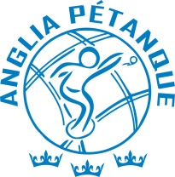 | Anglia Pétanque Association | 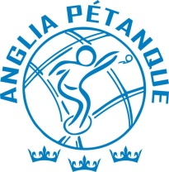

Triples Championship

Sunday 13th September 2026.

East Norfolk PC, Lingwood village hall, Station Rd, Lingwood, NR13 4AZ.

Entry, please list below Players Name, note: - Players initials will be published on the Anglia Facebook page to confirm entry once payment is received.

Player 1: -
Player 2: -
Player 3: -

Registration: 9.00am for a 9.30am Start.

Entry Fee: Entry to this competition is £10.00 per player.

Format: As per the Anglia competition rules.

Food: Café will be open til 11:30. Bring your own lunch.
Club bar will open at 12 noon, only alcoholic drinks purchase from the venue are to be consumed

Trophies: Medals & Prize money will be given for 1st & 2nd places, & the Plate, if played.

Entries to Playing Officer: Graham Beales, Town Green Farm, Gt Ellingham, Attleborough, NR17 1LP. Tel: 07770587495

Email: petanqueclub51@outlook.com

Please also CC Kevin Moss for confirmed entry and payment details, kevinmoss69@sky.com

Entry deadline: - 8.00pm Thursday 10th September 2026.

Payment must be paid online, details will be given once entry is received, no entry is confirmed until payment is received NO REFUND WILL BE GIVEN AFTER THE ENTRY DEADLINE.
Please also check Anglia’s Policy for Safeguarding and social media Policy before taking any photos, unless you have permission of the Regional Management Committee in Advance.

